Project 2 – Web Page

This project is a web page, but also carried multiple tabs and pages inside. I treated this project again, as a personal portfolio to display what I’ve done, and what I can do. To start this project, I used bootstrap templates that the professor suggested. I used one from the W3Schools Website. Using this template helped me because it gave me a guideline of what I wanted to do, and where things needed to be. I only used the bootstrap template for the first page, the welcome page. Now I’ll go into detail about each page I created, and how I did it.

Welcome Page:

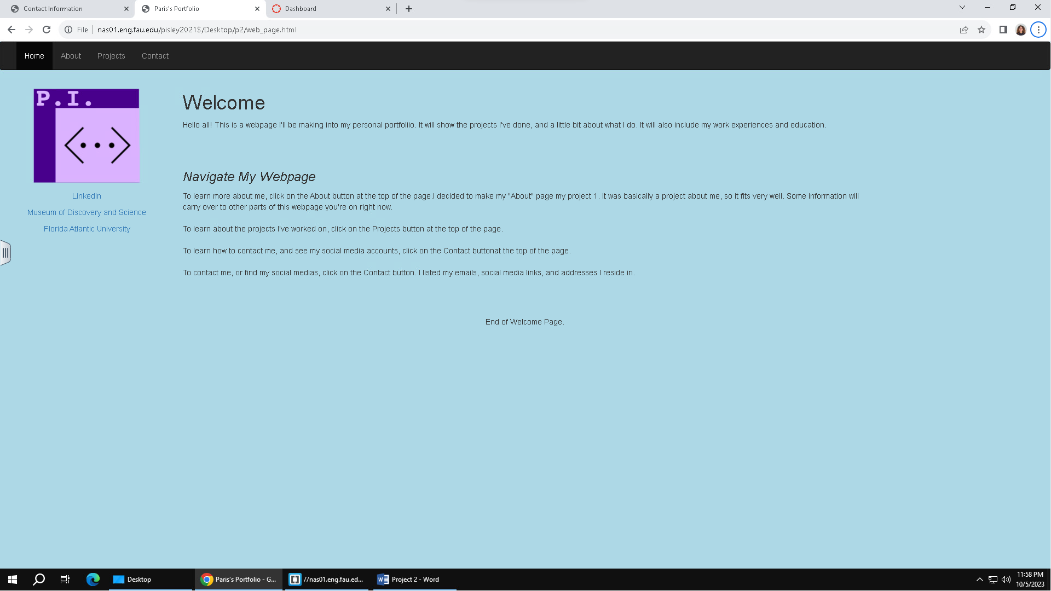

This is the first page the user will see when they open P2 on the index.html. On the top left corner, I added a personal logo to decorate. Under than I’ve added my frequently visited websites. There is a small intro about what you’ll be seeing on my website. The banner and layout of this page was made with Bootstrap. The header will be consistent in all the pages that live in this website. There is a CSS style page attached to the html file, that’s how I made the page blue and detailed the navigation bar.

About Page:

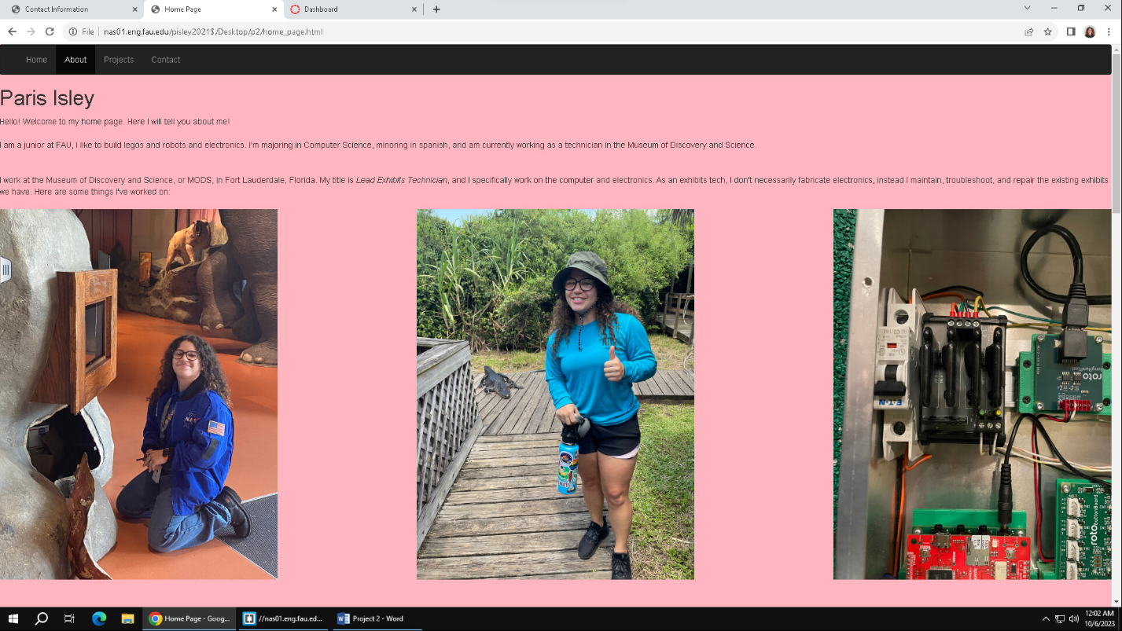

The About Page is the same page I used as my home page in P1, I thought it would be a good fit for this project as well. This page so far has the most CSS, with the aligning of the photos, and the div tags I had to use, it took a long time. You’ll see some repeat photos from this page on the Project Page I show next, I just chose the photos I thought would look the best. The background is pink, which I thought would be nice considering there isn’t much I’m able to do about styling and making the website look good. I am still learning how to jazz up basic HTML. You’ll notice that all the photos are evenly spaced , this may be easy to do as an expert, but it took me days to figure it out. Trying to size the photos correctly so that they are to scale, and look nice was a smaller issue, but it still took me some time.

Project Page:

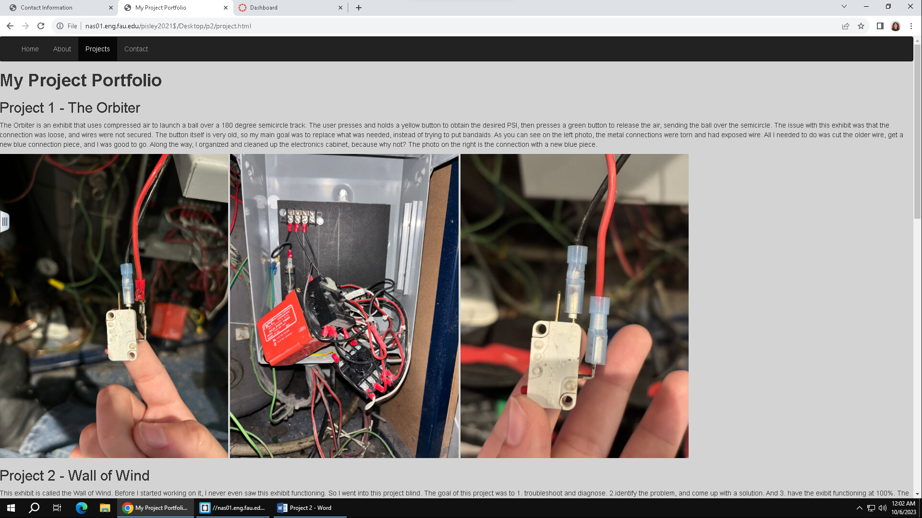

Similarly, to my About Page, my Project Page showcases things I’ve done professionally. Working as a technician, I deal with a lot of electronics and electrical projects. My major is technically computer science, but I have a strong passion and hobby in electronics. I have many projects I’ve done just for my personal interest as well. At my job, I’m responsible for the computer and electronic components, so whenever something goes wrong with those exhibits, they call me. Using the same techniques as I did for my About Page, I was able to order these images and texts.

Contact Page:

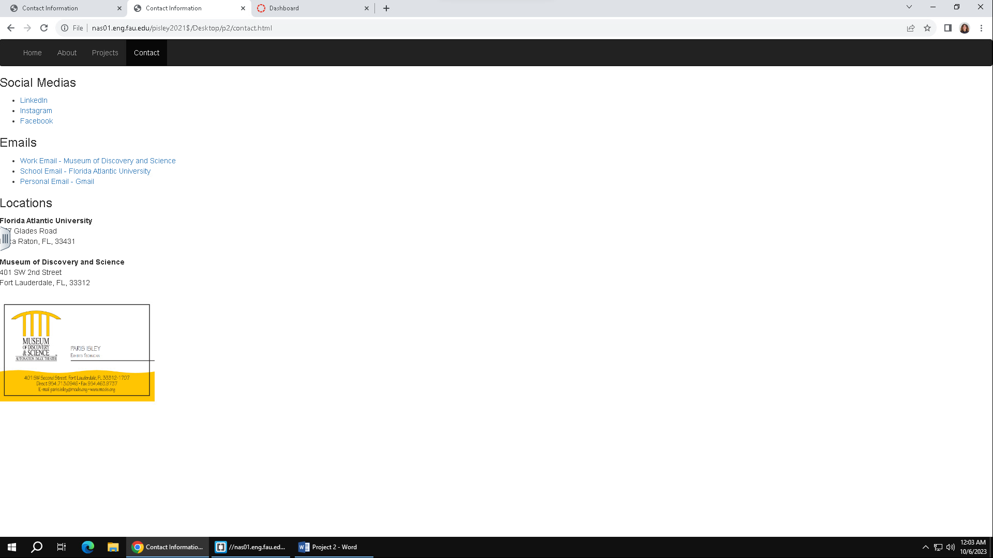

My Contact Page is fairly simple, no CSS involved, just straight HTML. I thought it would be important to include a contact page just like a real website would. I added my social media links, a better place to get to know me, the emails I am associated with, and the addresses I work and go to school at. I like using the <href> tag a lot in my projects, it gives me a sense of joy adding features that go beyond my one website.

So, that is my P2 assignment. A practical, enjoyable, personal portfolio. Hopefully later on I can keep adding to it and make it look better.